WEEK -01-Overview of C .Constants. Variables and data types

Week-01-01-practice session -coding

Reg no:241801289

Name :Tamilselvan.K

Q1)

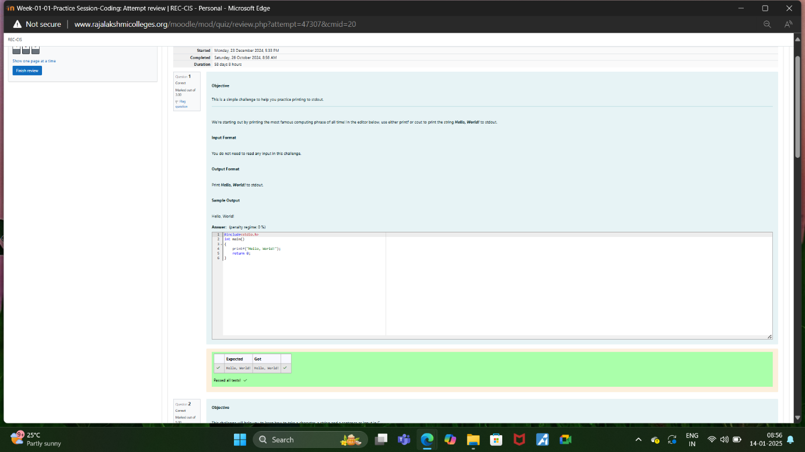

Week-01-01-practice session -coding

Reg no:241801289

Name :Tamilselvan.K

Q2)

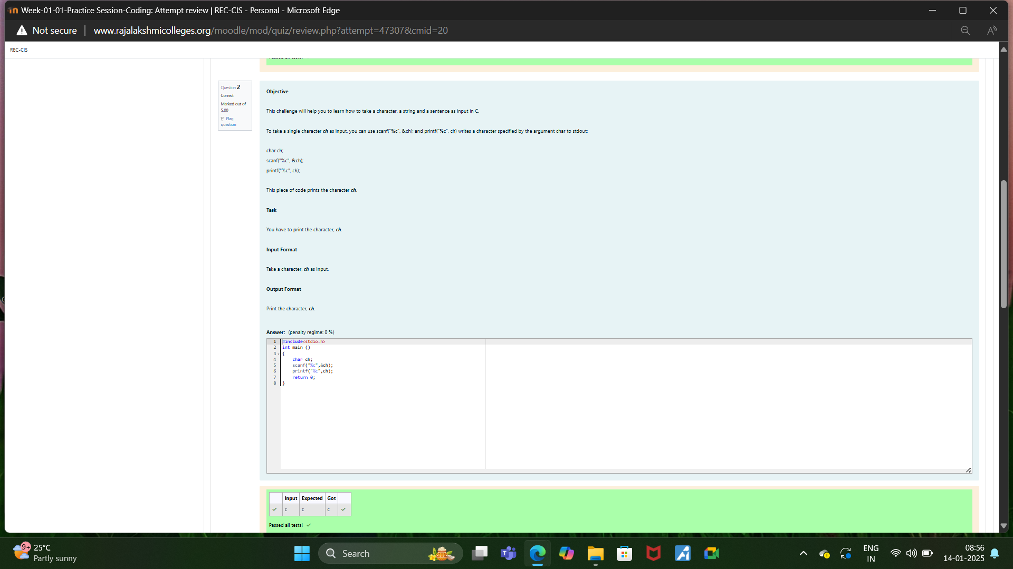

Week-01-01-practice session -coding

Reg no:241801289

Name :Tamilselvan.K

Q3)

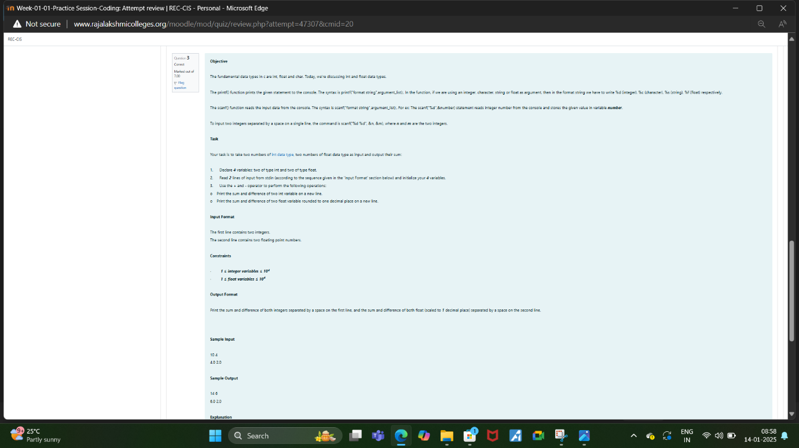

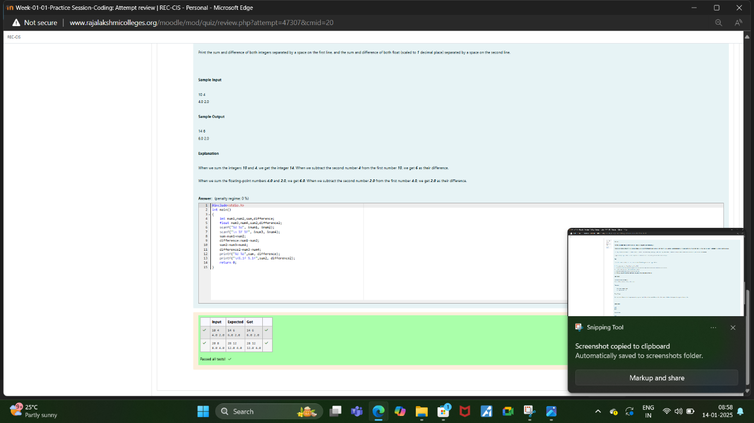

Week-01-02-practice session -coding

Reg no:241801289

Name :Tamilselvan.K

Q1)

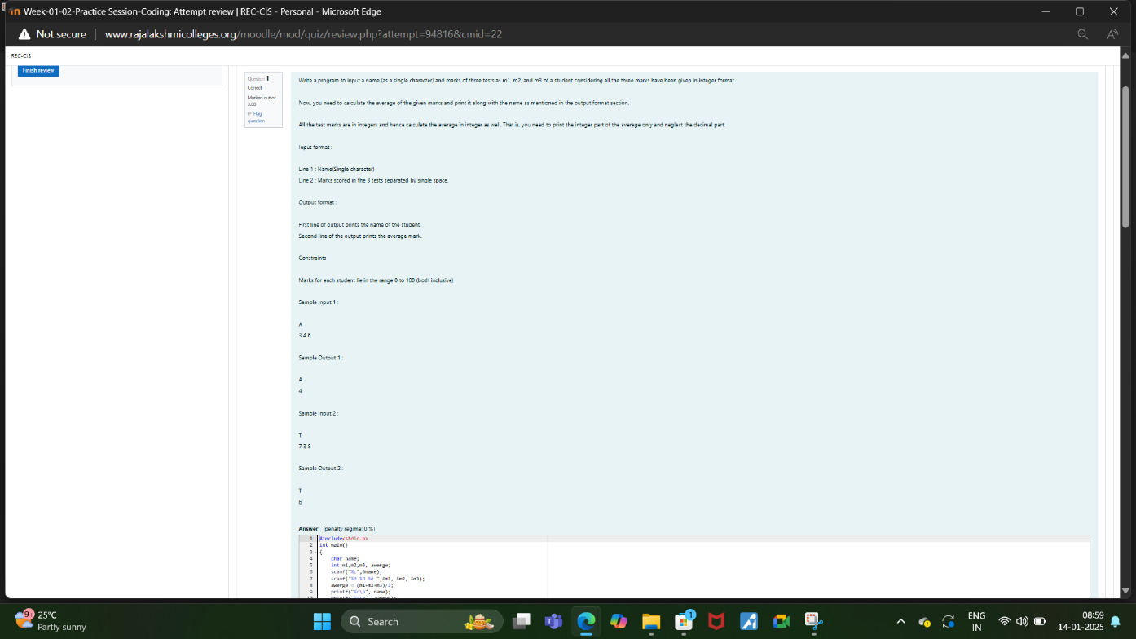

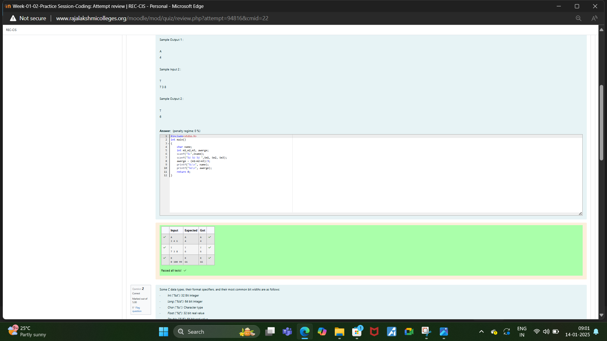

Week-01-02-practice session -coding

Reg no:241801289

Name :Tamilselvan.K

Q2)

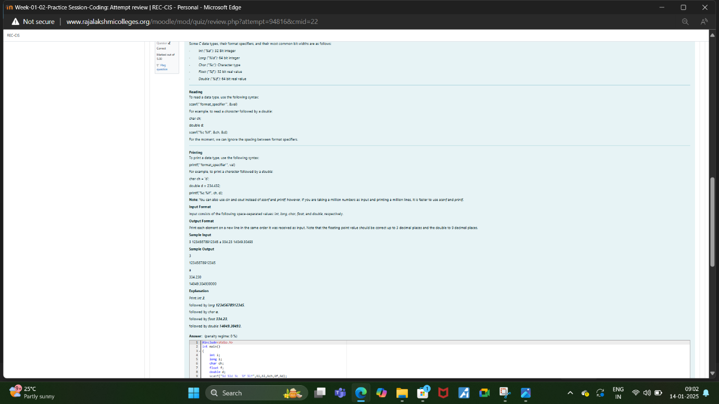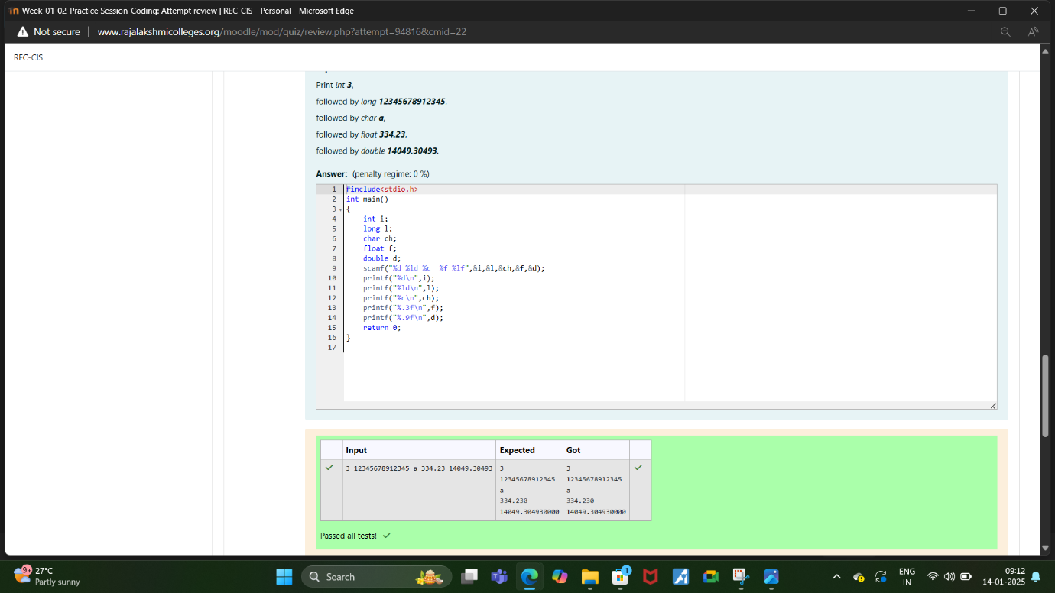

Week-01-02-practice session -coding

Reg no:241801289

Name :Tamilselvan.K

Q3)

